# **Template –** **Application for Graduation**

The template named “Template – Application for Graduation” is applicable to CampusNexus Student.

## Purpose and Outcome

This template provides a form sequence and supporting workflow for an Application for Graduation form to be submitted by a student. The sequence requires the following:

* A **Student record** must exist in the CampusNexus Student database.
* The student must have a **Portal login** to log into this authenticated sequence.
* The student must have a **credit card** to pay the fees associated with the application for graduation.

Forms Builder must support credit card payments using the PayPal or ACI payment gateways and must be configured for DocuSign. The template includes the steps required to collect a DocuSign signature from the student.

Upon completion of the sequence:

* The application for graduation form is added to the student record.
* The charge and payment are posted to the student’s ledger card.

## Prerequisites

The template was built in Forms Builder using the applications listed below. The template is forward compatible with later versions of the listed applications.

|  |  |
| --- | --- |
| **Application** | **Minimum Version** |
| Forms Builder Designer and Renderer | 3.4 |
| Web Client for CampusNexus Student | 19.0 |
| Workflow Composer | 2.6 |
| Packages installed from Package Manager in Workflow Composer | Activities and Contracts (V1) 19.0.0  Activities and Contracts (V2) 19.0.0  Forms Builder Contracts 3.4 |
| Workflow Tracking Database | N/A |
| Staff STS 2.0 | 2.0 |

## Step 1: Download and Import the Template

1. Download the template file (xml) to your environment (local drive or network location).
2. Log into **Forms Builder Designer**.
3. Click the **Export/Import** tile.
4. Select the **Import** tab.
5. Click **Select exported file** and navigate to the downloaded template file (xml).
6. Click **Import**.

* [Export/Import](https://help.campusmanagement.com/FB/3.x/Content/ExportImport.htm)

### The following forms will be imported:

### Application for Graduation

### Application for Graduation Payment

### Custom - Confirmation Standard No Auto Close

### Default-Frame (used with DocuSign)

## Step 2: In Form Designer…

1. From the **Forms** slide out, select the **Application for Graduation** form.

This form uses the following school defined fields:

* Diploma Name
* Commencement Sessions
* Cap Size
* Gown Size

Ensure that these fields are available in your CampusNexus Student database and that appropriate values are configured for each field. Delete the original fields and drag the new fields that you created onto the form.

1. Customize the form for your environment. Modify properties on current fields to make them required, etc., or add/remove fields on form.

Make sure you edit the text in the Labels and HTML controls as applicable for your institution.

* [Fields](https://help.campusmanagement.com/FB/3.x/Content/Fields.htm) and [Components](https://help.campusmanagement.com/FB/3.x/Content/Components.htm)

1. **Save** the form.
2. Repeat steps 1-3 for the following forms:

### Application for Graduation Payment

### Custom - Confirmation Standard No Auto Close

## Step 3: In Sequence Designer…

1. Select the **Application for Graduation** sequence.

The sequence contains the following forms in this order:

### Application for Graduation

### Default-Frame

### Application for Graduation Payment

### Custom - Confirmation Standard No Auto Close

1. Click **Save As** to create a copy of the sequence/workflow and customize the copy for your use. This way you can always refer to the original sequence/workflow you downloaded.
2. Optional - Add a custom style (theme) associated with your campus.

* [Themes](https://help.campusmanagement.com/FB/3.x/Content/Themes.htm)

1. Select your sequence in the Sequences pane.
2. In the Properties Pane:
   * Ensure that the **Authentication Product** is **Student**.

* Select the **End State Form** named “Custom - Confirmation Standard No Auto Close”.

1. **Save** the sequence**.**
2. Open the associated sequence workflow.

Depending on your environment, either click **Open Workflow** in Sequence Designer or launch a local installation of Workflow Composer.

* [Open the Workflows for a Sequence](https://help.campusmanagement.com/FB/3.x/Content/HostedEnv.htm)

## Step 4: In Workflow Composer…

1. Double-click the first form/state of the workflow named “Application for Graduation” and locate the and locate the activity named “**Find Document**”. This is a LookupReferenceItem activity.

In the **Reference Item** drop-down list, select a value that is appropriate for your environment.

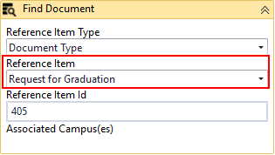

* [LookuoReferenceItem activity](https://help.campusmanagement.com/WF/Content/Workflow/LookupReferenceItem.htm?Highlight=lookupreferenceitem)

1. Scroll down to the **Assign Address Type** activity and update the hard-coded value of “26” with a value that is appropriate for your CampusNexus Student database. This is the address type that you have configured in your database.

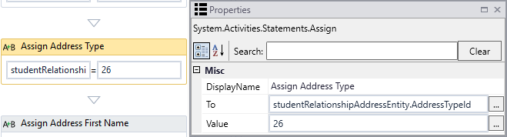

1. Scroll further down to the **Assign Amount** activity and update the hard-coded value of “75.00d” with your institution’s graduation fee.

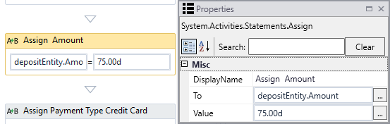

1. Double-click the **Submit** transition towards the end of the workflow and locate the **CreateCharge** activity.

Select **Charge Code** and **Transaction Type** values applicable to your environment.

Update the hard-coded **Amount** value of “75.00d” as appropriate.

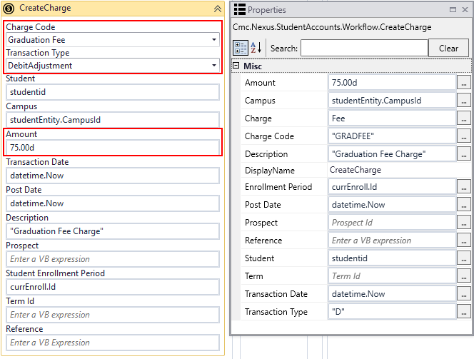

* [CreateCharge activity](https://help.campusmanagement.com/WF/Content/Workflow/CreateChargenew.htm)

1. Double-click the **End** state and locate the **CreateDocument** activity.

Select **Document Type** and **Document Status** values applicable to your environment.

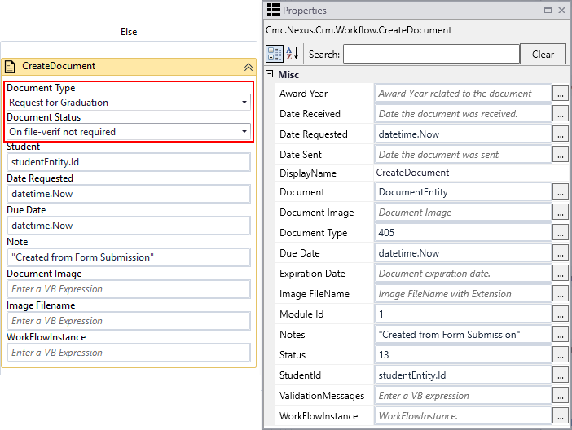

* [CreateDocument activity](https://help.campusmanagement.com/WF/Content/Workflow/CreateDocumentnew.htm?Highlight=createdocument)

1. Scroll down to the **Assign Status** activity and update the hard-coded value of “13” with a value that is appropriate for your CampusNexus Student database.

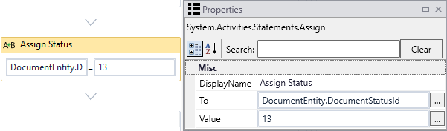

1. Scroll further down and locate the **CreateTask** activity.

Select an appropriate **Task Template.**

In the **Assign To field**,specifyaStaff Id value that is applicable to your environment.

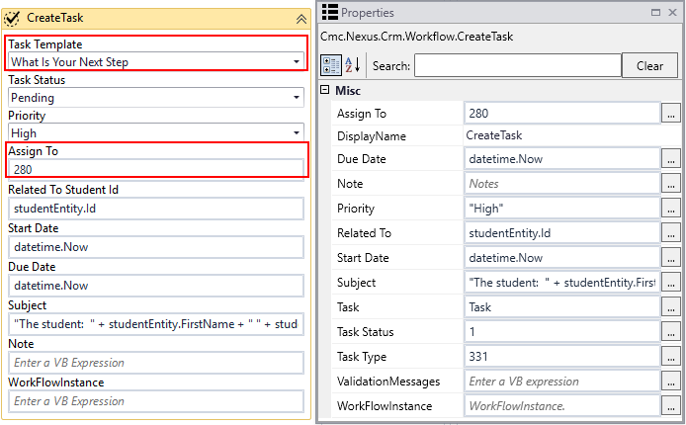

* [CreateTask activity](https://help.campusmanagement.com/WF/Content/Workflow/CreateTasknew.htm)

## Step 5: In Forms Renderer and CampusNexus Student…

Select your sequence and try it out!

* [Sequence List](https://help.campusmanagement.com/FB/3.x/Content/SequenceList.htm)

1. Find your **Application for Graduation** sequenceand copy the **URL** to the clipboard.
2. Log in to Portal as a **student** and complete the form sequence.
3. In CampusNexus Student,
   * Verify that application for graduation form is added to the student record.
   * Verify that the charge and payment are posted to the student’s ledger card.

## Step 6: Lastly…

Once your updated sequence has been tested successfully, it is recommended that you disable the workflow for the original Template version.

1. In Workflow Composer, in the Server section of the ribbon, click **Open**.
2. Find the workflow named “Transcript Request Form Sequence”.
3. Clear the **Enabled** check box and click **Save**.